****Year 11 Physics****

****Working Scientifically****

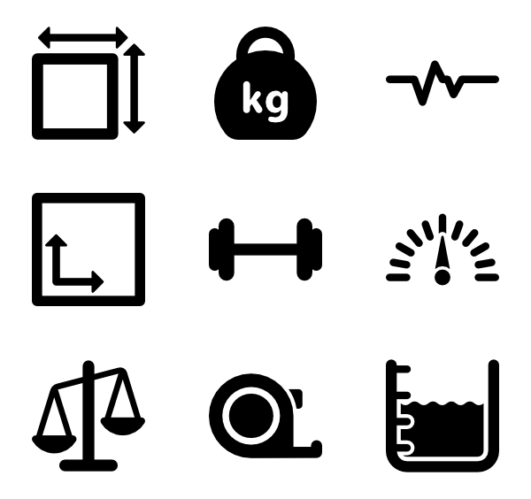

(Flaticon, n.d.)

**Name:**

****SCSA ATAR Syllabus****

<https://senior-secondary.scsa.wa.edu.au/syllabus-and-support-materials/science/physics>

* **identify, research, construct and refine questions for investigation; propose hypotheses; and predict possible outcomes**
* **design investigations, including the procedure(s) to be followed, the materials required, and the type and amount of primary and/or secondary data to be collected; conduct risk assessments; and consider research ethics**
* **conduct investigations, including using temperature, current and potential difference measuring devices, safely, competently and methodically for the collection of valid and reliable data**
* **represent data in meaningful and useful ways, including using appropriate Système Internationale (SI) units and symbols, and significant figures; organise and analyse data to identify trends, patterns and relationships; identify sources of random and systematic error and estimate their effect on measurement results; identify anomalous data and calculate the measurement discrepancy between experimental results and a currently accepted value, expressed as a percentage; and select, synthesise and use evidence to make and justify conclusions**
* **interpret a range of scientific and media texts, and evaluate processes, claims and conclusions by considering the quality of available evidence; and use reasoning to construct scientific arguments**
* **select, construct and use appropriate representations, including text and graphic representations of empirical and theoretical relationships, flow diagrams, nuclear equations and circuit diagrams, to communicate conceptual understanding, solve problems and make predictions**
* **select, use and interpret appropriate mathematical representations, including linear and non-linear graphs and algebraic relationships representing physical systems, to solve problems and make predictions**
* **communicate to specific audiences and for specific purposes using appropriate language, nomenclature, genres and modes, including scientific reports**

****Proposed timeline****

|  |  |  |  |  |  |
| --- | --- | --- | --- | --- | --- |
| **Wk** | **#** | **Topic** | **PowerPoint** | **STAWA Questions** | **Pearson Physics** |
| 1 | 1 | Units and Système International Prefixes | 1-28 |  | Appendices A, B |
| 1 | 2 | Scientific Notation and Significant Figures | 1-28 |  | Appendix C |
| 1 | 3 | Experimental Design | 1-28 |  | pgs 396-397,400 |
| 1 | 4 | Uncertainty and Percentage Error | 1-28 |  |  |
| 1 | 5 | Uncertainty in derived quantities | 1-28 |  |  |
| 2 | 1 | Thermal physics |  |  |  |
| 2 | 2 | Thermal physics |  |  |  |
| 2 | 3 | Thermal physics |  |  |  |
| 2 | 4 | **Task 1: Working Scientifically Analysis** |  |  |  |
| 2 | 5 | Thermal physics |  |  |  |
| 3 | 1 | Thermal physics |  |  |  |
| 3 | 2 | Thermal physics |  |  |  |
| 3 | 3 | Thermal physics |  |  |  |
| 3 | 4 | Thermal physics |  |  |  |
| 3 | 5 | Thermal physics |  |  |  |
| 4 | 1 | Thermal physics |  |  |  |
| 4 | 2 | Thermal physics |  |  |  |
| 4 | 3 | Thermal physics |  |  |  |
| 4 | 4 | **Task 2: Specific Heat Capacity of a Substance** |  |  |  |
| 4 | 5 | Thermal physics |  |  |  |
| 5 | 1 | Labour Day |  |  |  |
| 5 | 2 | Thermal physics |  |  |  |
| 5 | 3 | Thermal physics |  |  |  |
| 5 | 4 | Thermal physics |  |  |  |
| 5 | 5 | Thermal physics |  |  |  |
| 6 | 1 | Thermal physics |  |  |  |
| 6 | 2 | Thermal physics |  |  |  |
| 6 | 3 | Thermal physics |  |  |  |
| 6 | 4 | **Task 3: Thermal Physics Topic Test** |  |  |  |
| 6 | 5 | Line of best fit & gradient | 29-42 |  | Appendix C |
| 7 | 1 | Line of best fit & gradient | 29-42 |  |  |
| 7 | 2 | Line of best fit & gradient/Parent Teacher Interviews | 29-42 |  |  |
| 7 | 3 | Parent Teacher Interviews |  |  |  |
| 7 | 4 | Data manipulation for graphing | 29-42 |  |  |
| 7 | 5 | Data manipulation for graphing | 29-42 |  |  |

****Units****

7 fundamental units which all others can be derived from:

* Length: metre (m)
* Mass: kilogram (kg)
* Time: seconds (s)
* Electric current: ampere (A)
* Temperature: kelvin (K)
* Luminous intensity: candela (cd)
* Amount of substance: mole (mol)

Most formulae require the quantities to be in standard units so you must convert them; i.e. m/s not km/h

****Using equations to determine units****

* An equation can be used to find an unknown value when all others are known, it can also be used to find an unknown unit when all other units are known

Speed=distance/time

* Units for speed will be the units for distance over the units for time: m/s

Force=mass x acceleration

* Units for force will be the units for mass multiplied by the units for acceleration:   
  kg m/s2
* Units often have multiple names; kg m/s2 = N

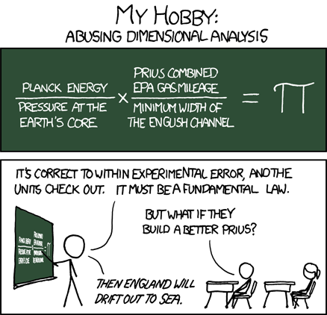

(Munroe, Dimensional Analysis, n.d.)

**For each of the following equations determine the units of the subject of the equations:**

1. **F=ma**
2. **P=mv**
3. **W=Fs**

****SI prefixes****

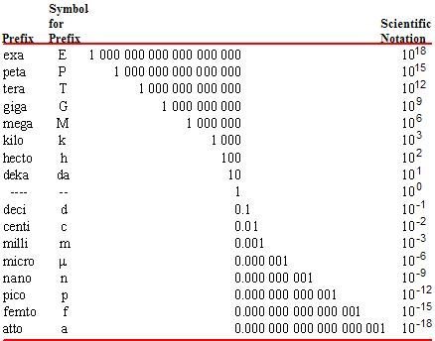

(Vitz, et al., 2016)

**Convert the following to standard units:**

1. **450 km**
2. **3.4 ns**
3. **7.7 µg**
4. **60 km/h**
5. **390 MN**
6. **20.0**

****Scientific notation****

* Very large or very small number are written as a number between 1 and 10 multiplied by a power of 10:

140000000 = 1.4x108

0.000000000345 = 3.45x10-10

* Generally don’t bother with numbers between 0.01 and 1000 but not incorrect to still use it

**Convert the following to scientific notation:**

1. **0.00000034532**
2. **1204000000**

****Significant figures****

* Non-zero digits are always significant
* Digits between significant figures are significant
* Zeroes that are BOTH after the decimal point AND at the end of a number are significant

**How many significant figures do each of the following have:**

1. **3.04**
2. **300**
3. **3.00**
4. **3.040**
5. **3040**

**Convert the following to 3 significant figures:**

1. **1395**
2. **0.0023909**
3. **450503**

* The number of significant figures in a measurement is the number of digits used in scientific notation.
* Calculated answers must not claim to be more precise than the original data.
* In general, give your answer to the fewest number of s.f. in the data.
* In Physics tests and exams three significant figures are required except for data analysis and estimations which are written to the fewest number of s.f. in the data or estimate.

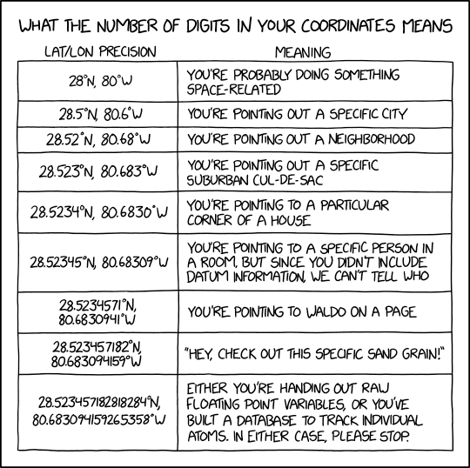

**40 digits: You are optimistic about our understanding of the nature of distance itself.**

(Munroe, 2019)

****Experimental Design****

An experiment should:

* Be valid
* Be reliable
* Have repeat trials to minimise random error
* Identify and eliminate sources of systematic error
* Be precise
* Be accurate

****Validity****

* A valid experiment tests what it aims to

Internal validity

* Was the experiment well designed
* Does the experiment clearly show that a change in one variable caused the change in another

External validity

* Are the result applicable beyond the immediate context of the experiment
* Is the relationship observed in a lab also applicable to the outside world

****Reliability****

* A reliable experiment produces results that can be replicated by another observer in a different lab using the same experimental set-up
* A reliable experiment returns the same answer every time it is performed regardless of who conducts it or where it is conducted

****Random Error****

* Always present in any measurement
* Caused by unknown and unpredictable changes in experiment
* Often has normal distribution so can be eliminated by taking the average of repeat trials
* Impacts precision

Examples include:

* Electronic noise in circuits of electronic equipment
* Irregular changes in air pressure, temperature, humidity etc. of the experiment area
* Parallax error, always viewing from a slightly different angle
* Sampling, selecting a sample rather than testing whole population
* Estimating a value between graduations

****Systematic Error****

* Normally cause by the measuring equipment or experimental design
* Predictable if understood, often constant or proportional to the measured value
* Impacts accuracy

Examples include:

* Incorrectly zeroing a scale
* Parallax (more often random), consistently viewing from the same angle

****Precision****

* Size of spread in repeat measurements; high precision = small range
* Related to the fineness of scale on instrument.
* I.e. the number of decimal places.

****Uncertainty****

* No measurement is exact
* Uncertainty is the range of values between which the scientist is confident the value lies, measure of precision

****Absolute uncertainty****

* Analogue: half of the finest scale of division on measuring instrument.
* Digital: half the smallest division it goes up in.
* It is an indicator of precision of measurement.
* e.g. 30 cm ruler with mm scale =
* 3.4g on electric scale =
* Sometimes reaction time and other circumstances must be taken into consideration.
* 10 swings of pendulum ÷ answer by 10 and uncertainty by 10
* Give absolute uncertainty rounded to the lowest place value in the quantity:

e.g. 3.45±0.15 not 3.45±0.2, and not 3.45±0.147393

****Absolute uncertainty with repeat trials****

* Measurement changes with each attempt e.g. water rocket, fluctuating needle.
* Absolute Uncertainty = ½ range of readings

****Absolute uncertainty with time intervals****

* When timing an interval with a stopwatch, 2 measurements are taken; start and finish
* The absolute uncertainties for each measurement must be added together
* Absolute uncertainty for a single stopwatch measurement is human reaction time (often 0.1s)
* Therefore; the absolute uncertainty for a time interval is often 0.1+0.1=0.2s

****Representing uncertainty****

* 128 + 0.5mm
* An example of absolute uncertainty in the actual measurement. (units same as for measurement)
* Can be shown as error bars on graphs
* Can have different values for each point

**Record the readings of each thermometer with its absolute uncertainty**

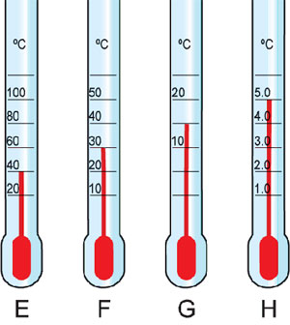

|  |  |  |
| --- | --- | --- |
| Thermometer | Reading | Absolute Uncertainty |
| E |  |  |
| F |  |  |
| G |  |  |
| H |  |  |

(Pearson Education, n.d.)

****Percentage uncertainty****

* Cannot always compare the uncertainties of two measurements meaningfully as absolute uncertainties

Percentage uncertainty is the uncertainty as a percentage of the measurement:

**Calculate the percentage uncertainty of the following measurements:**

1. **3.2±0.5 m**
2. **124±50 ms**
3. **143±0.5 cm**

****Relative uncertainty****

* Uncertainty relative to the measurement
* Serves the same purpose as percentage uncertainty, use either but be clear about which you are using

****Uncertainty in derived quantities****

* When adding or subtracting data, add the absolute uncertainties.
* When multiplying or dividing, add the % uncertainties (or relative uncertainties).
* Raising to a power n, multiply % uncertainty by n.

****Uncertainty and significant figures****

* The interaction between the different uncertainties and significant figures can be complex
* For our purposes give uncertainties to no more than 2 significant figures

**Find the absolute and percentage uncertainty of the density of water found from the data below:**

* **Mass of beaker + water: 81.2g**
* **Mass of beaker: 34.6 g**
* **Volume of liquid: 48 mL**

****More Examples****

1. A student measures the dimensions of a book to be 28.1 + 0.05 cm and 21.4 + 0.05 cm. Determine:
   1. a) The perimeter of the booklet with its absolute and percentage uncertainty in correct format.
   2. b) The area of the book with its absolute and percentage uncertainty in correct format.
2. 2. A piece of metal is found to have a mass of 136.4 g on a digital scale and displaces 7.0 + 0.5 mL of water. Determine the density of the metal with its absolute and % uncertainty.
3. 3. A rod has a radius of 5.6 + 0.05 cm and a length of 24.55 + 0.05 cm. Determine the volume of the rod with its absolute and % uncertainty.

****Accuracy****

* How close an answer is to the true value.
* Instrument and method used to measure data correctly
* Scale zeroed properly, tape measure not stretched, error of parallax minimized.

****Percentage error****

* Measure of accuracy
* Often an experiment will be conducted to determine the value of a constant, e.g. g=9.8ms-2
* Percentage error used to compare experimental value to accepted ‘true’ value

**Determine the percentage error for the following values**

1. **g=9.76**
2. **c=2.97x108**

**Measurement Exercise:**

Equipment: 100 mL beaker with approx 20 mL coloured water.

50 mL measuring cylinder

Scale + stone

1m ruler

Determine the absolute and percentage uncertainty of the following measurements.

1. The mass of a stone.
2. The length of your desk.
3. The volume of coloured water in a measuring cylinder and then in a beaker.

|  |  |  |  |  |
| --- | --- | --- | --- | --- |
| What to measure | Measurement | Absolute uncertainty | Calculate % uncertainty | Percentage uncertainty |
| Mass of stone |  |  |  |  |
| Length of desk |  |  |  |  |
| Width of desk |  |  |  |  |
| Volume in beaker |  |  |  |  |
| Volume in measuring cylinder |  |  |  |  |

1. Determine the surface area of table with its uncertainty in standard format. Show all working out.

(6 marks)

1. A cylindrical rod of steel has a diameter of 32.6 + 0.05 mm using a vernier caliper and a length of 238 + 0.5 mm using a 1 m ruler.
2. Determine the volume of the cylinder. (2 marks)
3. Determine the percentage uncertainty of the volume of the rod. (6 marks)
4. Determine the absolute uncertainty of the cylinder’s volume. (4 marks)

****Uncertainty in derived quantities practice****

1. A classroom has the dimensions: 11.4m long, 9.50m wide and 3.20m high, each measurement made to the closest dm (+0.05 m).
   1. Calculate the floor area in m2.

Determine the:

* 1. percentage uncertainty of the classroom area.
  2. absolute uncertainty of the classroom area.
  3. Calculate the volume of the classroom in m3.

Calculate:

* 1. The percentage uncertainty
  2. The absolute uncertainty of the classroom volume
  3. State the range of possible volumes for the volume of the classroom.

1. In the country airplanes are used to determine a car’s speed. A strip of road is measured to be 150 + 5 m and marked off. The plane measures the time a car takes to travel between the 2 marks. Mark’s car took 4.6 s. Reaction time at each side of the stopwatch measurement is 0.1s so the absolute uncertainty for the time is 0.2 s.
   1. What speed was Mark travelling at in m/s and km/h.
   2. The speed limit is 110 km/h should Mark be given a speeding fine?
   3. Calculate the percentage uncertainty in the measured speed of his car.
   4. Calculate the absolute uncertainty in the speed of the car and state the range of speeds at which the car may have been travelling according to the measurements.
   5. Was Mark definitely speeding?
2. **When renovating a house James needs to know how much skirting board and wooden flooring he should buy for a room that is 3.86m by 5.24m. James measured the room with a measuring tape with 1cm increments.**
   1. **What is the length of skirting board needed?**
   2. **What is the absolute uncertainty on this length?**
   3. **What is the minimum length of skirting board James should buy to ensure he has enough?**
   4. **What is the area of wooden flooring needed?**
   5. **What is the percentage uncertainty on this area?**
   6. **What is the absolute uncertainty on this area?**
   7. **What is the minimum area James should buy to ensure he has enough?**

**Answers**

1a) 108 m2 b) 0.965% c) 1.04 m2 d) 347 m3 e) 2.53% f)8.76m3 g) 338m3<V<355 m3

2a) 32.6 m/s and 117 km/h b) Yes c) 7.68% d) 9.01 km/h Range = 108-126 km/h e) No the range of his speed falls below speed limit.

**3a)18.2m b) 0.02m c) 18.4m d) 20.2 m2 e) 0.225% f) 0.0455 m2 g) 20.3m2**

****Graphs – Line of best fit****

* Draw in line of best fit as close as possible to all data points
* Outliers; if a single data point deviates far from the overall trend can potentially ignore, but be cautious
* If equation the trend should follow is known and there is no y-intercept term; can draw line through (0,0), otherwise don’t force it
* Extending the trend line beyond the data points is known as extrapolation; predictions based on extrapolation are suspect, stick to interpolation

****Linear equation****

**y = mx+c**

* Often convenient to plot graphs such that they will produce a straight line
* Achieved by manipulating the equation so it resembles the general equation for a linear relationship

**For each of the following equations identify the value plotted on the y-axis, value plotted on the x-axis, gradient and y-intercept**

|  |  |  |  |  |
| --- | --- | --- | --- | --- |
| **Equation** | **y-axis** | **x-axis** | **gradient** | **y-intercept** |
|  |  |  |  |  |
|  |  |  |  |  |
|  |  |  |  |  |

****Uncertainty for gradients****

* It may be necessary to determine the uncertainty for a gradient determined from a graph
* Draw in the steepest gradient that fits within the error bars and the shallowest gradient that fits within the error bars
* Determine the gradient for each of the two lines and find the difference, this is the range of gradients so halve it and use that as the uncertainty

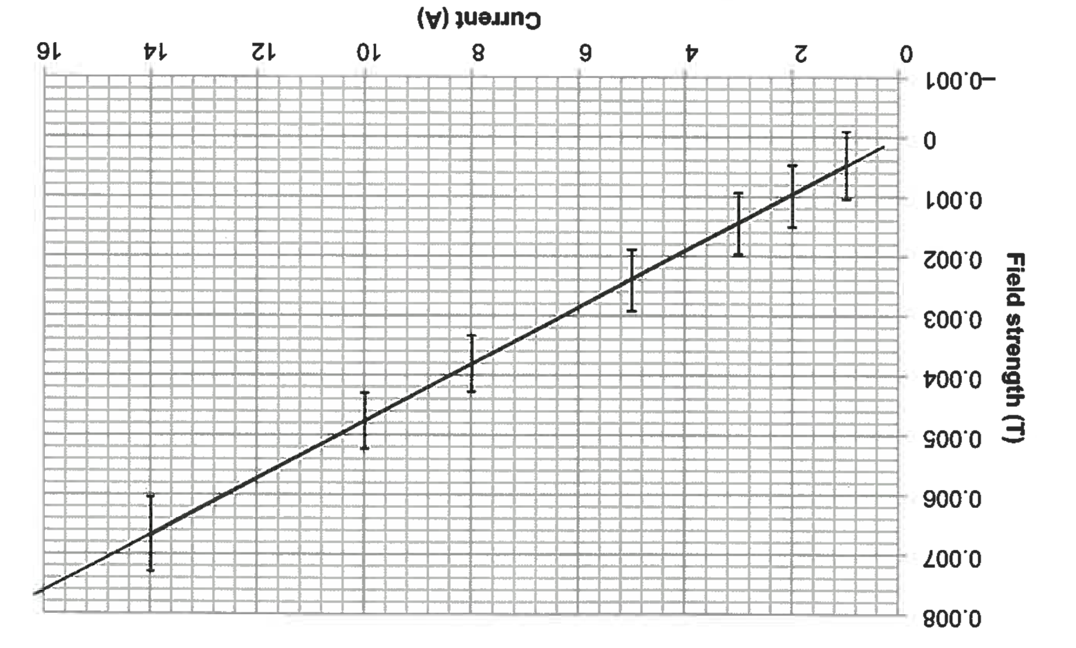**Determine the gradient of the graph below with uncertainty**

(Government of Western Australia, School Curriculum and Standards Authority, 2018)

**Data Manipulation Problem**

A 50g mass is placed on a variable slope to determine an experimental value for g**.**

Angle of a slope and normal force are thought to be related by the equation below:

The following data is recorded:

|  |  |
| --- | --- |
| N(N) | Θ(◦) |
| 0.490 | 0 |
| 0.483 | 10 |
| 0.460 | 20 |
| 0.424 | 30 |
| 0.375 | 40 |
| 0.315 | 50 |

Manipulate the data and plot a straight-line graph in order to determine the value of g.

|  |  |  |  |  |  |  |  |  |  |  |  |  |  |  |  |  |  |  |  |
| --- | --- | --- | --- | --- | --- | --- | --- | --- | --- | --- | --- | --- | --- | --- | --- | --- | --- | --- | --- |
|  |  |  |  |  |  |  |  |  |  |  |  |  |  |  |  |  |  |  |  |
|  |  |  |  |  |  |  |  |  |  |  |  |  |  |  |  |  |  |  |  |
|  |  |  |  |  |  |  |  |  |  |  |  |  |  |  |  |  |  |  |  |
|  |  |  |  |  |  |  |  |  |  |  |  |  |  |  |  |  |  |  |  |
|  |  |  |  |  |  |  |  |  |  |  |  |  |  |  |  |  |  |  |  |
|  |  |  |  |  |  |  |  |  |  |  |  |  |  |  |  |  |  |  |  |
|  |  |  |  |  |  |  |  |  |  |  |  |  |  |  |  |  |  |  |  |
|  |  |  |  |  |  |  |  |  |  |  |  |  |  |  |  |  |  |  |  |
|  |  |  |  |  |  |  |  |  |  |  |  |  |  |  |  |  |  |  |  |
|  |  |  |  |  |  |  |  |  |  |  |  |  |  |  |  |  |  |  |  |
|  |  |  |  |  |  |  |  |  |  |  |  |  |  |  |  |  |  |  |  |
|  |  |  |  |  |  |  |  |  |  |  |  |  |  |  |  |  |  |  |  |
|  |  |  |  |  |  |  |  |  |  |  |  |  |  |  |  |  |  |  |  |
|  |  |  |  |  |  |  |  |  |  |  |  |  |  |  |  |  |  |  |  |
|  |  |  |  |  |  |  |  |  |  |  |  |  |  |  |  |  |  |  |  |
|  |  |  |  |  |  |  |  |  |  |  |  |  |  |  |  |  |  |  |  |
|  |  |  |  |  |  |  |  |  |  |  |  |  |  |  |  |  |  |  |  |
|  |  |  |  |  |  |  |  |  |  |  |  |  |  |  |  |  |  |  |  |
|  |  |  |  |  |  |  |  |  |  |  |  |  |  |  |  |  |  |  |  |

**Data Manipulation Problem**

Conduction of heat in a solid is given by the equation:

Q = energy transferred (J)

t = time (s)

k = thermal conductivity ( ? )

A = cross-sectional area (m2)

∆T = change in temperature (K)

l = length (m)

2cm diameter aluminium rods of different lengths, temperature difference between the two ends was maintained at 75K, heat transferred was measures after 1 minute

1. manipulate data so you can get a straight-line graph
2. plot the straight-line graph, draw a line of best fit and determine the gradient
3. determine the thermal conductivity of aluminium with units

|  |  |
| --- | --- |
| Length (cm) | Heat (J) |
| 5 | 6700 |
| 10 | 3350 |
| 15 | 2230 |
| 20 | 1700 |
| 25 | 1350 |

|  |  |  |  |  |  |  |  |  |  |  |  |  |  |  |  |  |  |  |  |
| --- | --- | --- | --- | --- | --- | --- | --- | --- | --- | --- | --- | --- | --- | --- | --- | --- | --- | --- | --- |
|  |  |  |  |  |  |  |  |  |  |  |  |  |  |  |  |  |  |  |  |
|  |  |  |  |  |  |  |  |  |  |  |  |  |  |  |  |  |  |  |  |
|  |  |  |  |  |  |  |  |  |  |  |  |  |  |  |  |  |  |  |  |
|  |  |  |  |  |  |  |  |  |  |  |  |  |  |  |  |  |  |  |  |
|  |  |  |  |  |  |  |  |  |  |  |  |  |  |  |  |  |  |  |  |
|  |  |  |  |  |  |  |  |  |  |  |  |  |  |  |  |  |  |  |  |
|  |  |  |  |  |  |  |  |  |  |  |  |  |  |  |  |  |  |  |  |
|  |  |  |  |  |  |  |  |  |  |  |  |  |  |  |  |  |  |  |  |
|  |  |  |  |  |  |  |  |  |  |  |  |  |  |  |  |  |  |  |  |
|  |  |  |  |  |  |  |  |  |  |  |  |  |  |  |  |  |  |  |  |
|  |  |  |  |  |  |  |  |  |  |  |  |  |  |  |  |  |  |  |  |
|  |  |  |  |  |  |  |  |  |  |  |  |  |  |  |  |  |  |  |  |
|  |  |  |  |  |  |  |  |  |  |  |  |  |  |  |  |  |  |  |  |
|  |  |  |  |  |  |  |  |  |  |  |  |  |  |  |  |  |  |  |  |

# References

(n.d.). Retrieved from Flaticon: https://www.flaticon.com/free-icons/measure_1591

Government of Western Australia, School Curriculum and Standards Authority. (2018, October 25). *Physics, ATAR course examination, 2017.* Retrieved from Physics - Past ATAR course exams: https://www.scsa.wa.edu.au/publications/past-atar-course-exams/physics-past-atar-course-exams

*Pearson Education*. (n.d.). Retrieved from http://wps.pearsoned.com.au/sf2_2/134/34366/8797766.cw/content/index.html

Vitz, E., Moore, J. W., Shorb, J., Prat-Resina, X., Wendorff, T., & Hahn, A. (2016, May 19). *1.4: SI Prefixes*. Retrieved from LibreTexts: https://chem.libretexts.org/Textbook_Maps/General_Chemistry_Textbook_Maps/Map%3A_ChemPRIME_(Moore_et_al.)/01Introduction%3A_The_Ambit_of_Chemistry/1.04%3A_SI_Prefixes